To Change Address-------------------





**Phyu Min Tun Company Limited**

No.23, B/2, Sunirum Park, Thukhawaddi Street, Yankin Tsp, Yangon Myanmar.

el: +959 500 6225/ +959 517 5867

Cover Photo ---------

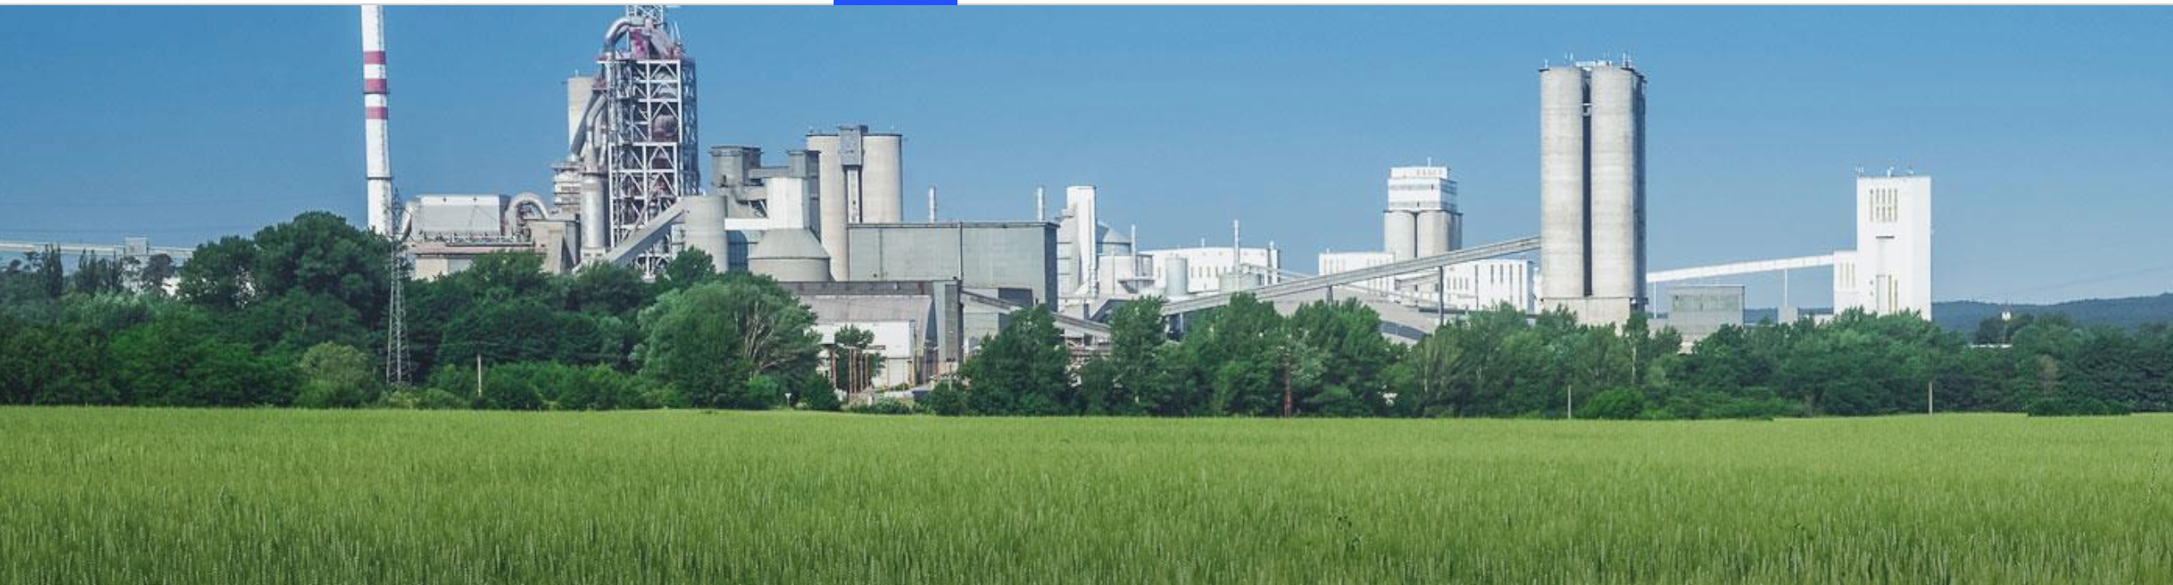

IF you need to insert -----------------



